Log In

* The Customer clicks the Log In button on the Home Page.

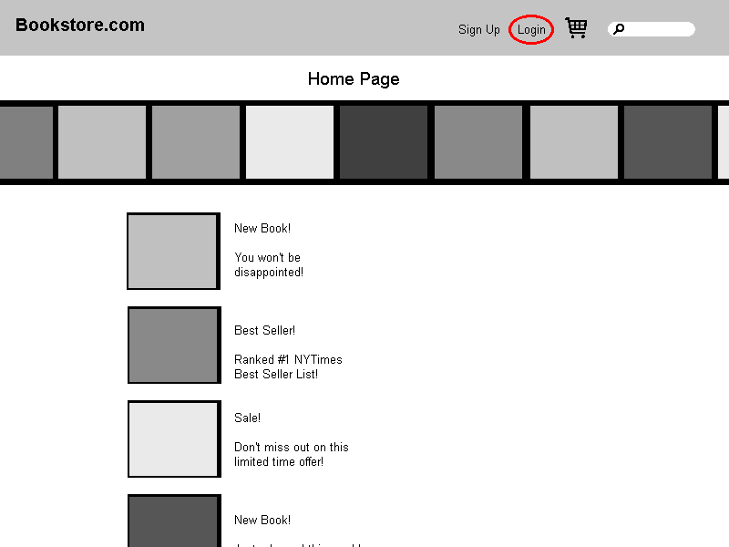

* The system displays the Login Page.
* The Customer enters his or her user ID and password and then clicks the Log In button.

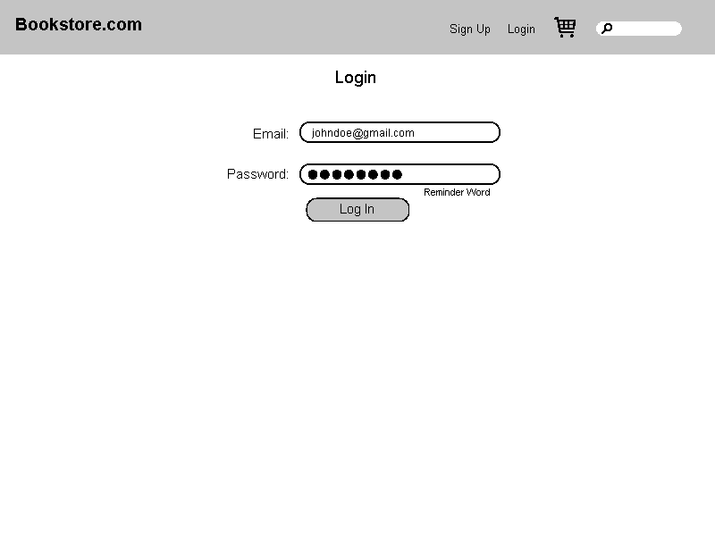

* The system validates the login information against the persistent Account data and then returns the Customer to the Home Page.

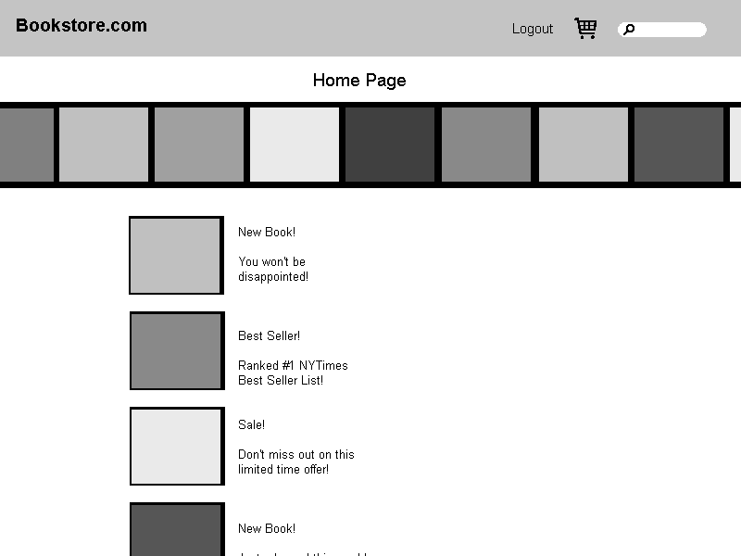

* + If the Customer clicks the New Account button on the Login Page, the system invokes the Open Account use case.
  + If the Customer clicks the Reminder Word button on the Login Page, the system displays the reminder word stored for that Customer, in a separate dialog box. When the

Customer clicks the OK button, the system returns the Customer to the Login Page.

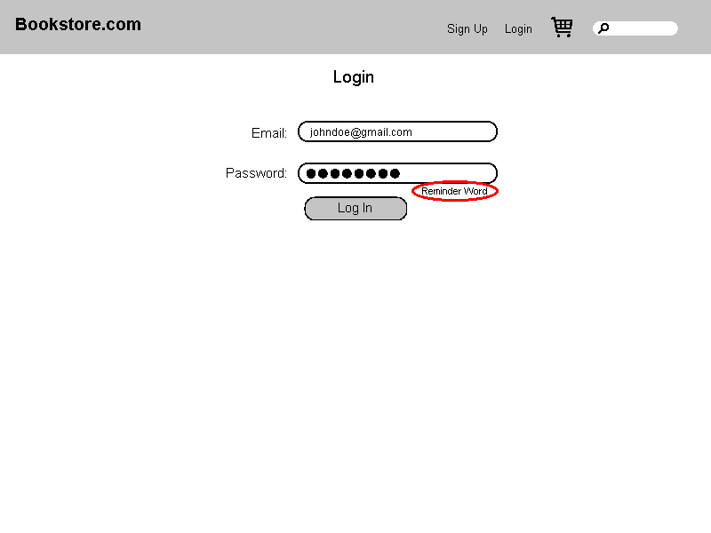

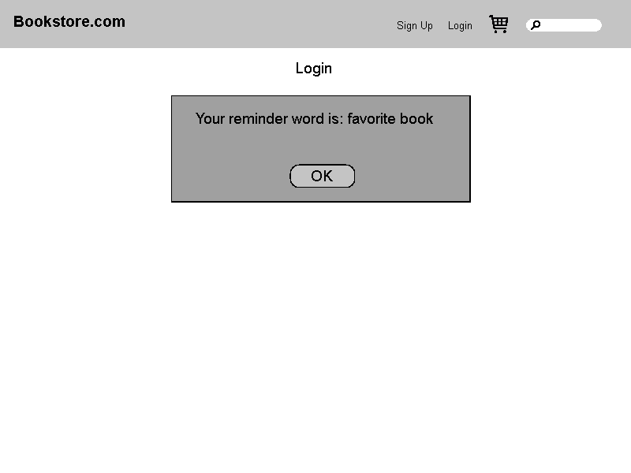

* + If the Customer enters a user ID that the system does not recognize, the system displays a message to that effect.

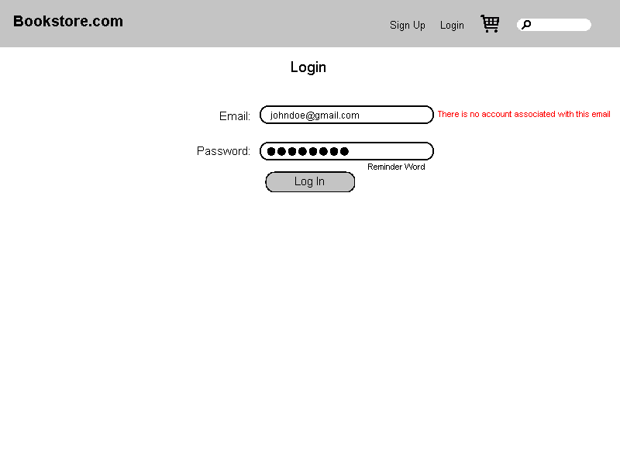

* + If the Customer enters an incorrect password, the system displays a message to that effect and prompts the Customer to reenter his or her password.

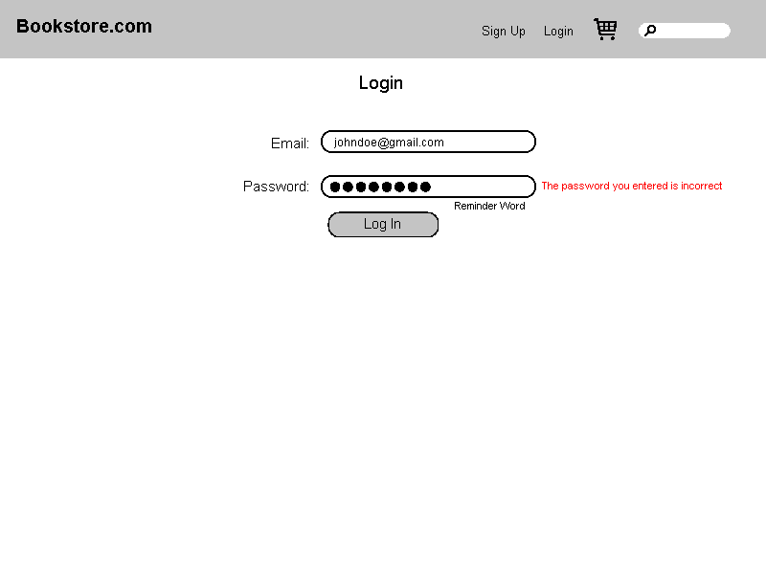

* + If the Customer enters an incorrect password three times, the system displays a page telling the Customer that he or she should contact customer service, and also freezes the Login Page.

